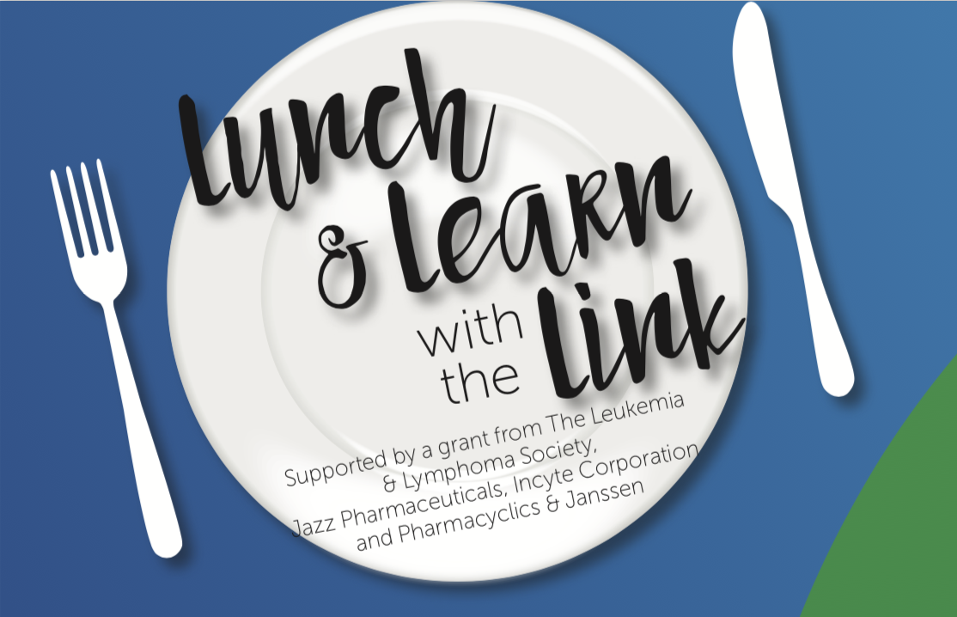

The nbmt LINK’s Lunch & Learns Are Off the Hook!

Our popular Lunch & Learns are pulling in registrations in record numbers. These live, FREE
call- in events, 11-14 per year are usually set for the third Wednesday of the month. These one hour audio programs are not only resulting in hundreds of patients, caregivers and health care professionals participating live but because they are recorded, they are being clicked on later, when the time is right. Listeners love the format—20 minutes with a highly regarded health care professional speaker, 10 minutes of a patient sharing their journey and about half an hour for live questions.

“We’re so happy to be able to meet people where they are, sometimes live, sometimes later whenever they need guidance and inspiration, whether in the middle of the night, or while waiting to be seen by a doc—on their timeline,” said Peggy Burkhard, the Executive Director of the nbmtLINK. “Topics such as cGVHD, fatigue, nutrition, light intervention, mindfulness, and fertility preservation are timely and appreciated. This year we added anxiety and despair that my cancer will return, how to get the most of your doctor appointments, a holistic approach to pain AML awareness, clinical trials and caregiver support to the lineup. In light of the recent pandemic, we have also added several special cancer related COVID-19 programs. Visit www.nbmtlink.org, then click on Lunch & Learn to see all of our programs. “

